DEACS Customized Recycling Outreach Materials Order Form
DEACS offers free graphic design services for all NC local governments via a variety of templates created for recycling and compost programs. We fulfill orders as quickly as possible. These free services are in high demand. If your request is from our templates and your order form is complete, our turnaround time is generally less than 3 weeks. If you have an idea beyond what is within the order form templates or have any questions about the order form, email mel.gilles@ncdenr.gov. Once you submit your order and receive our first draft, email back quickly with any edits to keep your order moving forward. We are looking forward to working with you!
Please call us to talk over any questions or ideas you have. We are glad to help!
Organization Contact Information
Please enter information below as you would like it to appear on the materials requested. For example: County/Municipality Name: Town of Jonesville Solid Waste Department

Please attach a high-resolution file of your logo. .EPS, .AI or .PNG preferred. If you can’t get a version in any of those formats, we will work with .JPEG or .PDF.
County/Municipality Name:
Any additional contact information (address, phone number, website, email, etc.):
Project Contact Information
Project Contact Name:
Phone Number:
Email:
Timeline & Dates
Today’s Date: |  |  |  | Target Date of Completion:
Are you a DEACS grantee? | YES NO |  |  | If yes, what is the contract year?
Who is your DEACS grant manager?
Will the materials requested be printed with grant funds? |  |  |  |  | YES NO
Recyclables Accepted: Please click on the following link to find the current materials accepted List in your community. https://deq.nc.gov/conservation/recycling/recycling-directories-and-maps/nc-mrfshed-map
Does this list match your own understanding of the materials accepted through your recycling program? If not, please list changes here:
 | - Curbside Single-Stream Recycling Accepted List/Magnet | 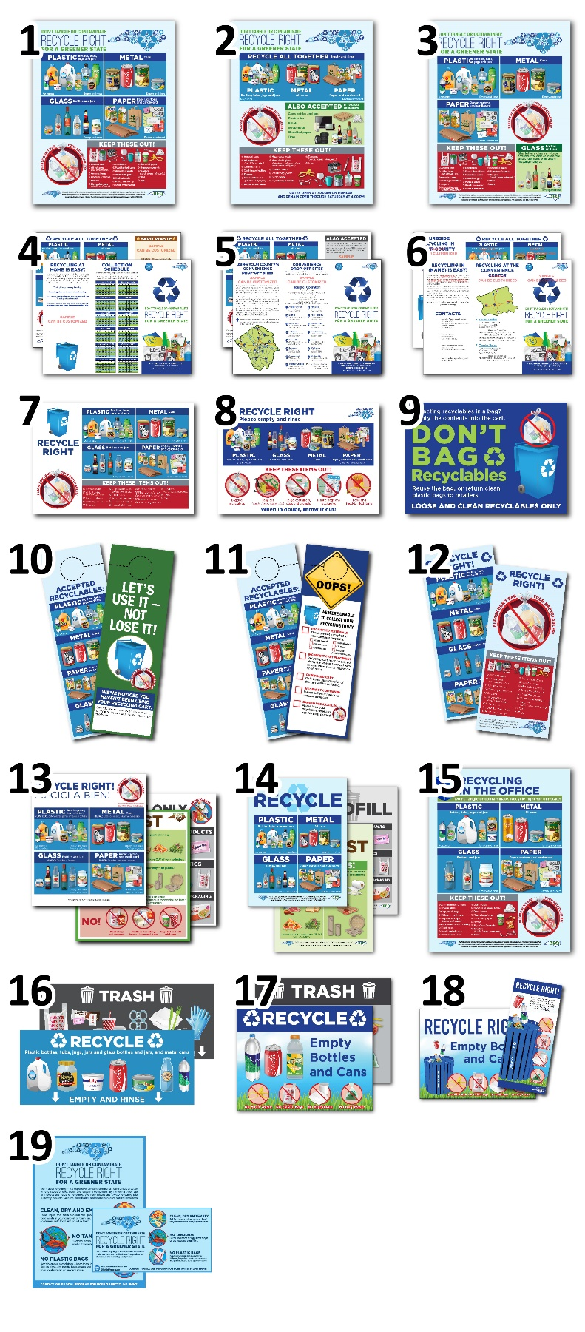
 | - Convenience Center Recycling Accepted List
 | - Glass Out Recycling Accepted List
 | - City Curbside Brochure
 | - County Drop-off Brochure
 | - Curbside and Drop-off Brochure
 | - Postcard with Extended “Not Accepted in Recycling” List
 | - Postcard with Simplified “Not Accepted in Recycling” List
 | - “Don’t Bag Recyclables” Postcard
 | - “Oops!” Curbside Cart Tag
 | - “Use it, Not Lose it” Curbside Cart Tag
- Accepted Recycling List
Mail Insert/Rack Card
 | - Curbside Cart Decals (Recycle, Compost and Trash)
 | - Recycle, Compost and Landfill Signs
 | - Office Recycling Accepted List
 | - Office Bin Decals (Recycle and Trash)
 | - Park bin decals (Recycle and Trash)
 | - Park Yard Signs and Rack Card
 | - Ads (Print, bus, etc.)

 | - Tourist-Branded Recycling Outreach Materials |  | 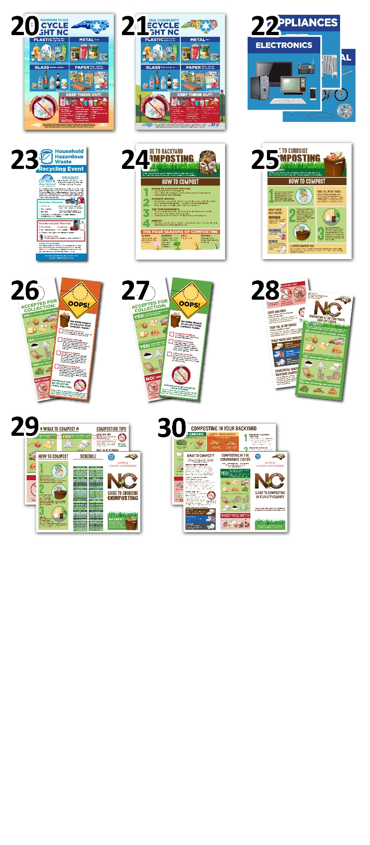
Accepted List  Magnet  Postcard  Door Hanger  Rack Card  Barrel Decals  Station Banner |  | Promo Material Designs (Tote bags, Keychains, Frisbees, etc.)  ___________  ___________  ___________
 | - Multi-Family Outreach Materials
Accepted List  Magnet  Postcard  Door Hanger  Rack Card  Barrel Decals  Station Banner |  | Promo Material Designs (Tote bags, Keychains, Frisbees, etc.)  ___________  ___________  ___________
 | - Convenience Center Signs
Single stream  Aluminum Cans  Steel Cans  Paper  Plastic  Glass  Cardboard  Scrap Metal  Electronics |  | Appliances  Furniture  Trash  Construction & Demolition  No Plastic Bags  ___________  ___________  ___________
 | - HHW Event Rack Card
 | - Guide to Backyard Composting
 | - Guide to Curbside Composting
 | - Food Waste “Oops!” Tag
 | - Food and Yard Waste “Oops!” Tag
 | - Composting at the Drop-off Center Mail Insert/Rack Card
 | - Curbside Composting Brochure
 | - Backyard and Drop-off Composting Brochure

PLEASE LIST ANY CHANGES AND SPECIFY THE DIMENSIONS FOR THE REQUESTED MATERIALS HERE
- Please provide any links to recycling pick-up schedules, convenience center addresses etc. that will be of reference.
- If ordering a brochure, please include the information that you want to see in the yard waste panel or the “Also Accepted at the Convenience Center” panel.
- Please specify if you would also want a Spanish-translated version of the requested materials (or a combined English and Spanish version).

